Product Specification Confirmation

Customer Name：Sonikcell Co.Ltd
Customer No.：
Product：Life Po4 SBMS 8S24V20A Common Port Balance
Version：Rev 2.0

Confirmation

Verified | Approved | Operation

Customer Acknowledgement

remarks：

Sign: Date：

Note：Upon acceptance of sample, please sign the acknowledgement back, the picture in the specification catalogue may diravate from the real used machine.
Document Issue/Edition

Version | Date | ECN No. | Contents
V1.0 | 2018.05.05 | / | Initial issue

Catalog
1．Product Summary…………………………………………………………………3
2．Product Character…………………………………………………………………3
3．Product Picture……………………………………………………………………4
4．Electric Parameter…………………………………………………………………5
5．Product Measurement……………………………………………………………6
6．Connection ………………………………………………………………………7
7．Operation Guidance………………………………………………………………8
8．Warranty…………………………………………………………………………9
9．Attention Items…………………………………………………………………9

1．Product Summary：
8S Life Po4 24V20A is product designed and developed by Sonikcell Co/.Ltd for mobile Lithium battery, it is widely used to 8S lithium battery pack, Life Po4 Battery
The BMS is functioned to prevent lithium battery from over charging, over discharging, short circuit, and it helps voltage balance.

2. Product charaters
- Adopt Japan premium IC in class A protection.
- Strong load capacity, continous high discharging current, adopt MOSFET which is in high voltage resistance and low conduct inner resistance, with dissipation to prevent over heat.
- IC is with voltage balance funtion, which function is simple and reliable and current balance can be made by adjustment.
- it is voltage detection to realize protection of over charging and discharging, over current, short circuit, the function of short circuit is stable and reliable, long time of loading in short circuit will not impact to BMS and core battery.
- proper temp control in charging and discharging.
- Well sealed detection resistance with high power, low temp deviation, 1%precision0.
- extremly low electricity consumption, the runing current is less than 100uA.
- Adopt sealt waterproof process, the product has waterproof, dustproof, shockproof, extrusion prevention, the utilization life is 2 times of the other same products.
- supportive of 8SLife Po4 Battery pack in series connection.

3.Product Picture：
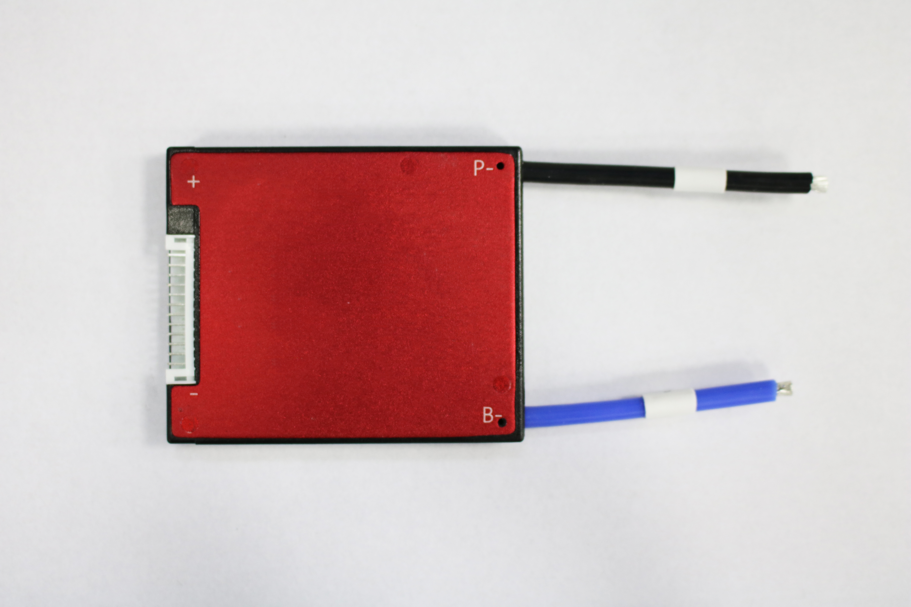

Finished product display

4.Electrical Parameters
 | Description | Specification | Unite | Remarks
Discharge | Continue discharge current | 20 | A
Discharge | Sparkle current | 75 | A
Charge | Charge voltage | 29.2 | V
Charge | Charge current | 20（MAX） | A
Over charge protection | Over charge detect voltage | 3.65±0.05 | V
Over charge protection | over charge protection delay | 0.5 | S
Over charge protection | over charge release voltage | 3.6±0.05 | V
Balance | Balance detect Voltage | 3.6 | V
Balance | Balance release voltage | 3.6 | V
Balance | Balance current | 35±5 | mA
Over discharge protection | Over discharge detect voltage | 2.5±0.1 | V
Over discharge protection | Over discharge detect delay | 0.5 | S
Over discharge protection | Over discharge release voltage | 2.5±0.1 | V
Over current protection | Over current detect voltage | 200 | mV
Over current protection | Over current detect delay | 9 | MS
Over current protection | Over current protection current | 75±10 | A | as required
Over current protection | Over current protection release condition  condition | Off load
Short Circuit protection | Short Circuit protection condition | Short circuit of external load ofext load short con
Short Circuit protection | Short circuit detect delay | 250 | uS
Short Circuit protection | Short circuit protection release condition | Off load
Temp Protect |  |  |  | No
Inner Resistance | Main Circuit Conduct Inner resistance | ≤10 | mΩ
Self Consumption | Working current | ≤100 | uA
Self Consumption | Sleeping current(when in discharge) | ≤20 | uA
Working Temp | Temp range | -20/+80 | ℃

5.BMS Measurement（Unit：mm）
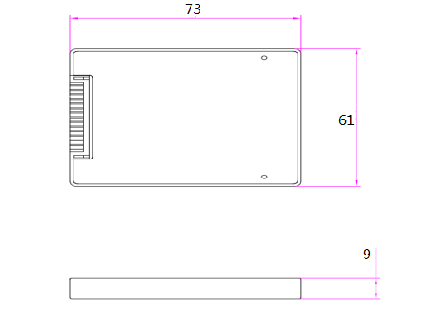

6.Connection

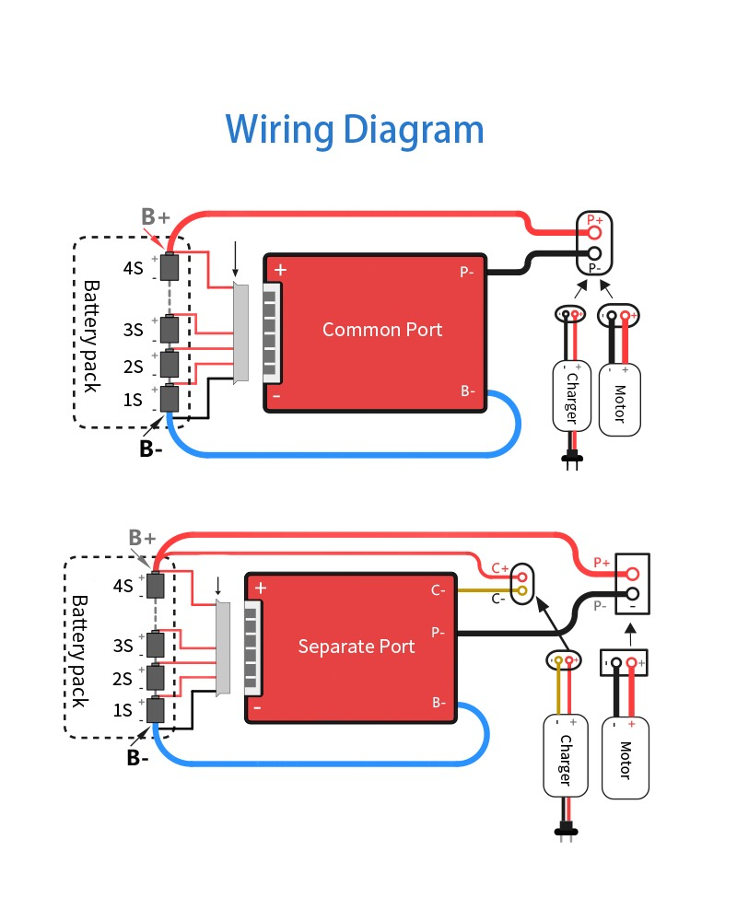

7．Operation Guidance

7.1.Special attention
- String wires are in differnent standard by different manufacture, please ensure to use our gifted matched string wires
- Please make sure to strictly follow up with the operation sequence, if you violate the operation sequence, It may damage BMS parts, even with more serious damage.

7.2.Operation process：
1．First to connect BMS B- wire(Thick Blue wire) to Battery Cathod
2．Ensure not to insert string wires into BMS before string conncetion
3．Connection starts from the Thin black wire B-, connect the second wire(thin red wire) to the first serious battery Anode, then follow the sequence to connect every cell anode, till to the last cell B+
4．Complete the strings connection, please do not insert into BMS directly, but measure the voltage of every 2 closed insert end, for Li-ion battery, the voltage should be 2.8-4.2V, For Life Po4 battery, the voltage should be 2.5-3.65, For Lipo Battery, the voltage should be 1.6-2.8V
5．When ensure string connection and voltage are all correct, then insert into BMS
6．Then measure Voltage of Battery B+ and B- same with Voltage of P+ and P-, if same means BMS working normally, if not same, please recheck with the above operation process.
7．If BMS needs to be taken off from battery pack, please operate in the backward sequence.

8．Warranty

All our produced Lithium battery BMS, we guarantee 3 years warranty in quality, if the damage is caused by human improper operation, we will conduct repair with charge

9．Attention Items

1.Lithium batery BMS with different voltage platform can not be used mutaully, eg., Life Po4 SBMS can not be used for Li-ion battery
2.In utilization, please to make sure to Follow up the designed parameter and utilization conditions
3.Charge and discharge current can not be higher than the quoted current value in specification.
4.Please to utilize the BMS in the the regulated working temperature range, and make sure of the well heat dissipation environment
5.No self taking off and change parts in BMS
6.Our product has the function of waterproof, but still suggest avoid of long time water immersion.
7.We conduct Anode Oxidation process in BMS dissipation plate, but when the Oxidation layer destroid, it stll may electricity conductive, it is stll suggest to avoid Dissipation plate contact with Cell and Nickel band.

